Using bash scripting to create VDO (virtual disk optimizer) disk.

Project:
Configure VDO on your centos8 server using bash scripting as per following using /dev/sdb as block device:
- create a volume group using VDO as ”vdo1”.
- volume size should be 3GB.
- the volume group should be called ”myvg_vdo
- the logical volume size must be 1GB, and should be called ”mylv_vdo”.
- format it using xfs file system type.
- the mount point should be called /myvdo_part.
- mount it to the mount point called /myvdo_part.
- make persistent at any boot up or reboot.
- verify that VDO has been successfully created.

Solution:
Using bash scripting to perform or configure VDO can be challenging since it is complex and needs particular attention. Most of the time we use command line to perform it, but here it is different because we are configuring a single script to run it. Let us do it the very simplest way.
Note: before performing this project, we have added a new disk to our centos8 server and the new block device disk is /dev/sdb where the VDO will be performed.
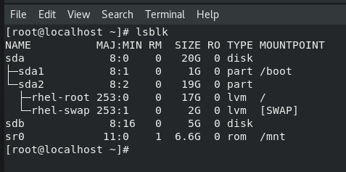

- As root user, create the script file called myvdo_script.
#touch myvdo_script
- Access the file and edit the followings:
#!/bin/bash
PACKAGE=”vdo kmod-kvdo”
If yum –y install $PACKAGE
then
echo ”starting and enabling vdo services”
systemctl start vdo
systemctl enable vdo
echo ”Creating the volume group as vdo1”
vdo create - -name=vdo1 - -device=/dev/sdc - - vdoLogicalSize=0.003T
echo ”Creating the physical volume”
pvcreate /dev/mapper/vdo1
echo ”Creating the volume group and logical volume”
vgcreate myvg_vdo /dev/mapper/vdo1
lvcreate –L +0.001T –n mylv_vdo myvg_vdo
echo ”Making it a xfs file system and creating the mount point”
mkfs.xfs –K /dev/mapper/myvg_vdo-mylv_vdo
mkdir /myvdo_part
echo ”Mounting the vdo and Making it persistent”
mount –t xfs /dev/mapper/myvg_vdo-mylv_vdo /myvdo_part
/dev/mapper/myvg_vdo-mylv_vdo /myvdo_part xfs defaults,x-systemd.requires=vdo.service 0 0”>> /etc/fstab
echo ”Verifying the vdo creation”
df –h
lsblk
vdo list

fi

- Save and quit.
The file content should look like this:
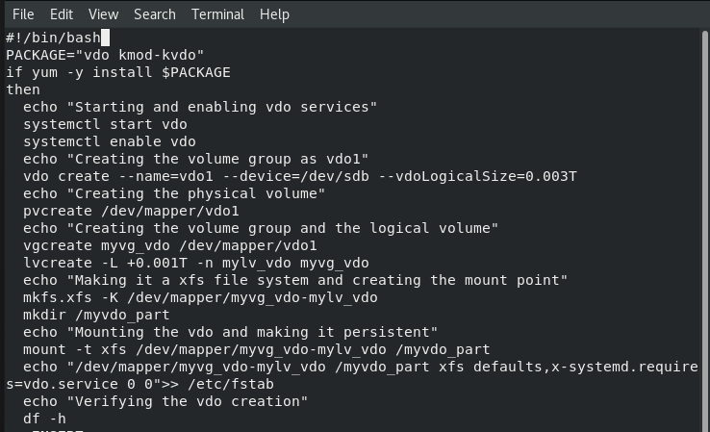
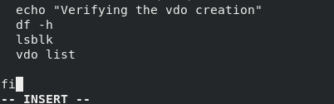
3-give the execute permission to the file.
#chmod +x myvdo_script
4-run the script.
#sh myvdo_script
